Docker Desktop Docker Desktop: The #1 Containerization Tool for Developers | Docker
Git Git - Install for Windows
winget install DuckDB.cli
winget install OpenJS.NodeJS.LTS
Open 2 PowerShell sessions as Administrator

docker version
docker compose version
git --version

mkdir Project
cd Project
copy in ..\Project\customer_support_tickets.csv

git clone https://github.com/lakekeeper/lakekeeper.git
cd lakekeeper\examples\minimal
docker compose up -d

docker compose ps

You should eventually see the main services running or healthy, including:
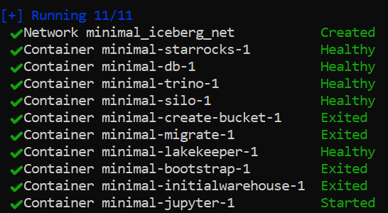

The one-time bootstrap, migrate, create-bucket, and initialwarehouse containers may show Exited (0). That means they completed successfully.
Open:
http://localhost:8181/ui/
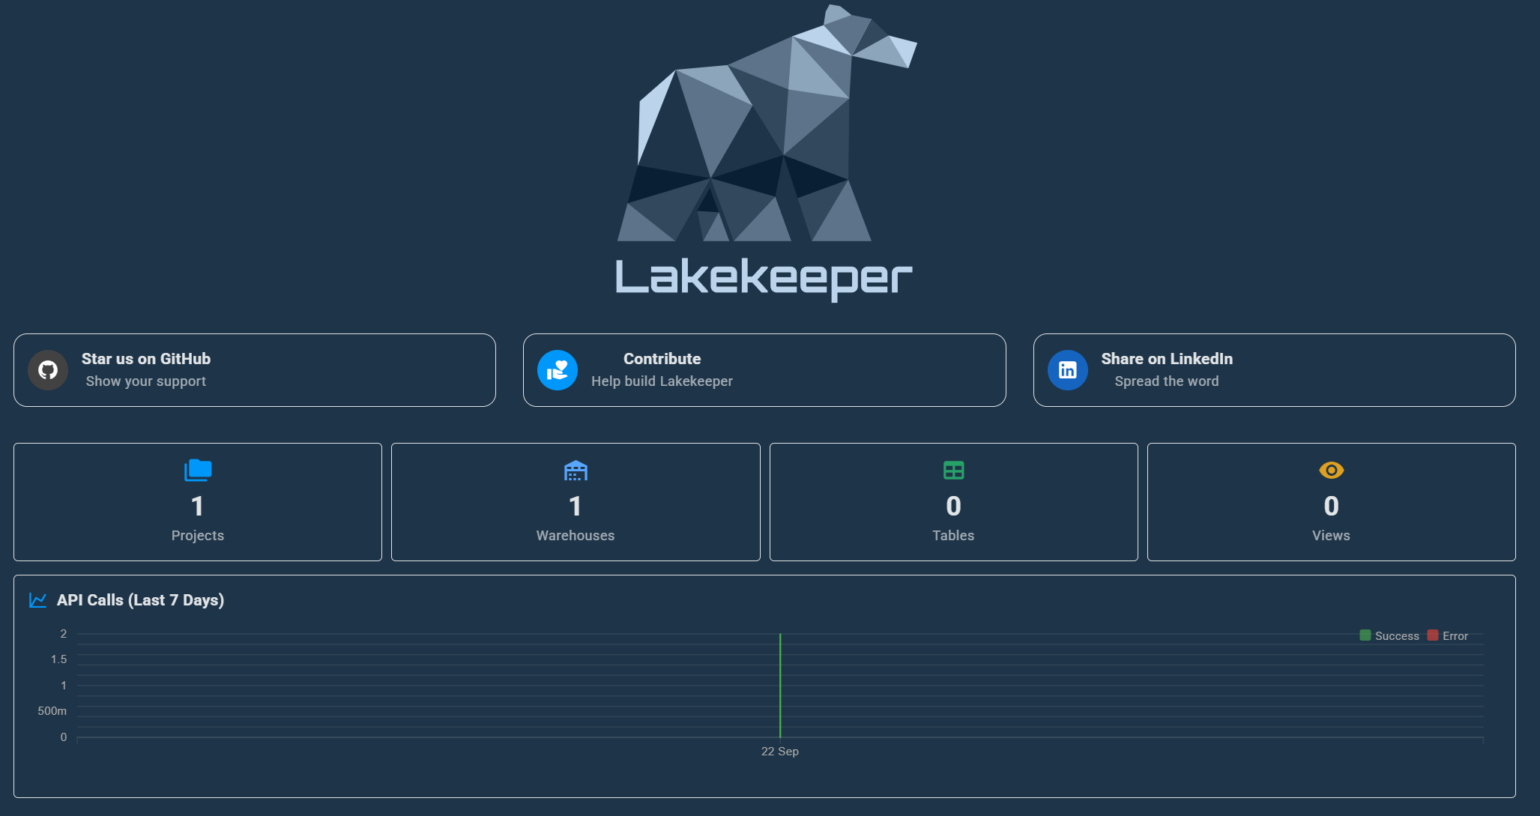
The REST endpoints are:
Purpose | URL
Lakekeeper UI | http://localhost:8181/ui/
Iceberg REST API | http://localhost:8181/catalog
Management API | http://localhost:8181/management
API documentation | http://localhost:8181/swagger-ui
These are the current documented Lakekeeper endpoints.
PowerShell:

Get-Content .\create-default-warehouse.json
"warehouse-name": "…"

Verify it is “demo”

curl.exe "http://localhost:8181/catalog/v1/config?warehouse=demo"

in DuckDB

INSTALL iceberg;
INSTALL httpfs;
LOAD iceberg;
LOAD httpfs;

CREATE TABLE tickets AS SELECT * FROM read_csv('customer_support_tickets.csv');
ATTACH 'demo' AS iceberg_catalog (
TYPE ICEBERG,
ENDPOINT 'http://localhost:8181/catalog',
AUTHORIZATION_TYPE 'none'
);

SHOW ALL TABLES;

CREATE SCHEMA iceberg_catalog.analytics;

CREATE TABLE iceberg_catalog.analytics.tickets AS
SELECT *
FROM main.tickets;
SHOW ALL TABLES;

SELECT * FROM iceberg_catalog.analytics.tickets

PowerShell
docker compose port silo 9000
curl.exe http://localhost:9000
notepad \windows\system32\drivers\etc\hosts
Add entry for 127.0.0.1 silo
ping silo
docker compose exec trino trino

trino> CREATE CATALOG lakekeeper USING iceberg
WITH (
"iceberg.catalog.type" = 'rest',
"iceberg.rest-catalog.uri" = 'http://lakekeeper:8181/catalog',
"iceberg.rest-catalog.warehouse" = 'demo',
"iceberg.rest-catalog.nested-namespace-enabled" = 'true',
"iceberg.rest-catalog.vended-credentials-enabled" = 'true',
"iceberg.unique-table-location" = 'true',
"fs.native-s3.enabled" = 'true',
"s3.region" = 'local',
"s3.path-style-access" = 'true',
"s3.endpoint" = 'http://silo:9000'
);
SHOW CATALOGS ;
exit
cd ..\..\..
copy in ticket_iceberg_dashboard.zip
expand-archive .\ticket_iceberg_dashboard.zip
cd .\ticket_iceberg_dashboard\
npm.cmd install
npm.cmd start

